Cate Fitzpatrick

To be used alongside Dr Neal Snooke’s turtlebot

Turtlebot Application User Manual

Contents

Introduction 2

Using the application 2

Launching the application 2

Writing your first program 3

Resetting the virtual turtle 4

Clearing the current program 5

Stopping the running program 6

Changing the font size 7

Connecting to the turtlebot 8

Selecting a port 8

Setting up the turtle 8

Run the program on the turtlebot 9

Adjusting the pen height 10

Saving and loading files 11

Saving your code 11

Loading a file 12

Inserting premade characters and shapes 14

Setup wizard 15

Troubleshooting 16

No ports are showing as available 16

Turtlebot is still not connected after following the steps 16

The USB port turned red 16

Developing the application 17

Adding new commands 17

Adding new insert shapes 17

Within existing shape types 17

With a new shape type 17

Changing the information/about pages 17

# Introduction

Welcome to the turtlebot application. This application allows you to learn and practice coding with Python by controlling a turtlebot either virtually or with a physical one.

Use the turtle to draw lines and shapes. The possibilities are endless and only limited by your imagination and table space.

This manual is divided into two parts. The first provides guidance on how to use the features of the application, including how to connect to the turtlebot. It additionally includes some common troubleshooting advice. The second section provides guidance on changing or altering the application in future.

# Using the application

## Launching the application

To launch the application, do the following steps:

1. Find where the application is saved and open the Turtlebot folder.
2. Click on the Turtlebot.exe to open it.

## Writing your first program

1. Type in the code box, as seen outlined in red, to write your program.

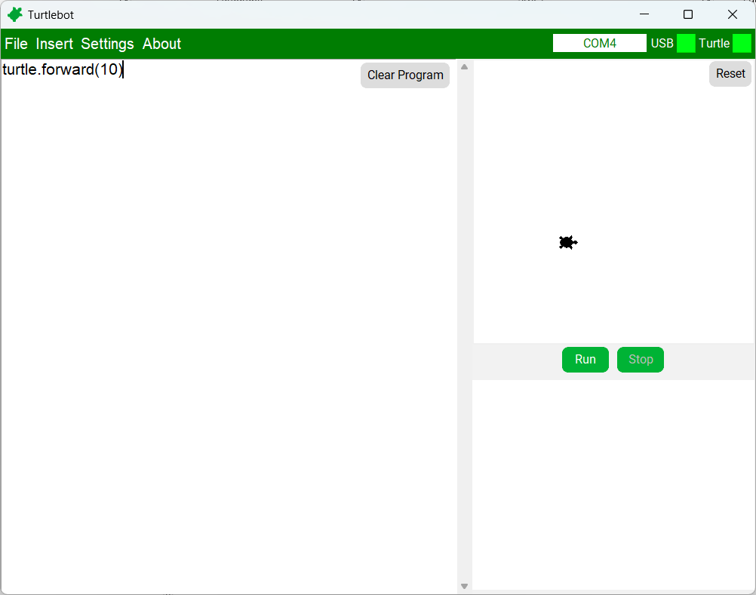

1. Type in the commands you wish for the turtle to do.

1. Press Run

1. Well done! You have run your first program.

### Resetting the virtual turtle

To clear the current turtle drawing, press the reset button.

### Clearing the current program

To delete the current program, press the Clear Program button.

### Stopping the running program

Press the stop button to stop the program whilst it is running.

### Changing the font size

1. Click on Settings on the top bar.

1. Hover over Font size

1. Click on the desired font size.

1. Both the code box and output text will now match the size specified

## Connecting to the turtlebot

### Selecting a port

1. Click on Settings on the top bar.

1. Click Select port.

1. Click the drop down and select your wanted port.

* 1. A screenshot of a computer

     AI-generated content may be incorrect.If no ports are shown as available, check the USB dongle is plugged in and click Refresh ports.

### Setting up the turtle

1. 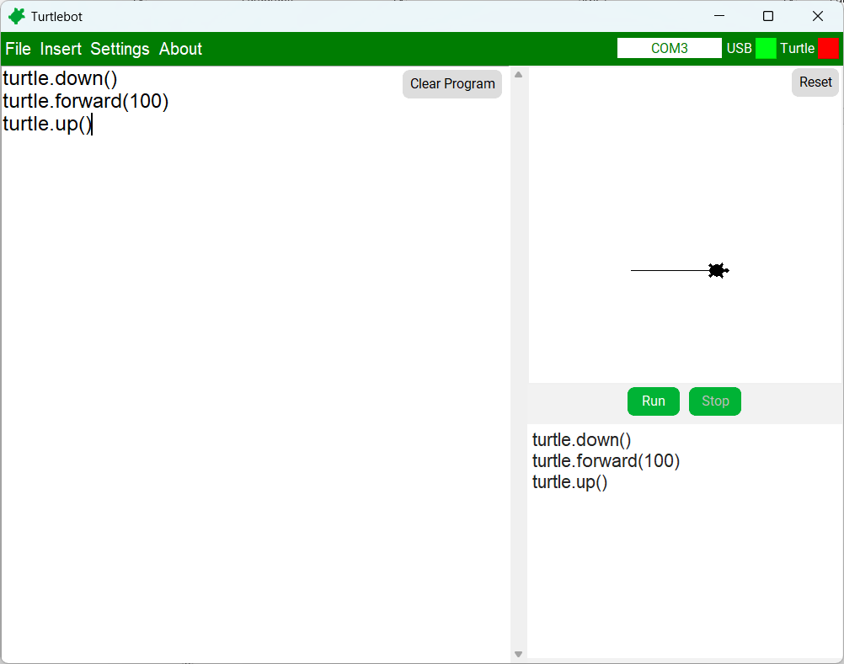Wait for the red box next to the word USB to turn green,
2. Press the button on the turtlebot to the right of the display screen.
3. A green and purple plastic toy with a small display

   AI-generated content may be incorrect.The red box next to the word Turtle will turn green and the turtlebot will display the message “Hello”. (This may take a moment)

### Run the program on the turtlebot

1. Now the turtlebot is connected commands can be run by pressing the run button like running the commands on just the virtual turtle.

## Adjusting the pen height

1. Click on Settings on the top bar when the turtlebot is connected.

1. Click on Pen height.

1. Drag the slider until the turtlebot’s pen just touches the paper underneath.

1. Once you're happy, press save.

## Saving and loading files

### Saving your code

1. Click on File on the top bar and then click Save.

1. Navigate to where you want to save your file and give it a name.

1. Click save.

### Loading a file

1. Click on File on the top bar and then click Load.

1. Navigate to the code you want to load and click it.

1. Click open.
2. The code will appear in the code box.

## Inserting premade characters and shapes

1. Click on Insert on the top bar.
2. Hover over desired insert type

1. Click on wanted insert option.

1. The code to make the shape will appear in the code box.

## Setup wizard

1. Connect the turtlebot.
2. Click on Settings on the top bar then Setup Wizard

1. Make sure you have the listed equipment available, and press Start.

1. Read the instructions and press Start. The turtlebot will move backwards

* 1. Press the Moved button if the turtlebot moves forward
  2. Press the No difference button if the turtlebot

1. Once done, the application will move to the next screen. The backlash has then been configured
2. Put the turtlebot on one end of the paper, facing the paper and press Draw
3. Measure the length of the line drawn and enter the value. Once entered press next
4. If the value matches the expected value it will move onto the next stage. Otherwise it will repeat steps 6 and 7
5. Put the turtlebot onto the middle of the paper and press draw

1. Measure the gap/overlap of each of the circles drawn and enter the two values

* 1. If there is a gap, put a minus symbol before the number
  2. It does not matter which value goes in which length box

1. When done, press Done. If the value matches the expected value, it will move onto saving. Otherwise, it will repeat steps 9 and 10
2. Press close to finish. The turtlebot is now claibrated

## Troubleshooting

### No ports are showing as available

* Check the USB dongle is plugged in.
* Try clicking on the refresh ports button.

### Turtlebot is still not connected after following the steps

* Try waiting a moment, then re-pressing the turtlebot’s button
* If the turtlebot still will not connect, check that the lights on the turtle's Bluetooth module and the USB dongle are both solid. If they aren’t, press the buttons on both.
* Try redoing the steps to connect the turtlebot.

### The USB port turned red

If left idle for too long, the port connection will close. Just refollow the steps to reconnect the port

# Developing the application

## Adding new commands

Each new command needs a counterpart for it, created within the User_Turtle class for the user to code in. The new function can then be programmed to send the corresponding command to the Port_Manager class.

If a change for the turtle simulation is required, then a Turtle Graphics command will need to also be sent to the Turtle_Simulation class. If the new command requires moving the Turtle_Simulation’s function to work out the needed turtle scale will also need to be added to in order to keep the turtle in view when carrying out commands.

## Adding new insert shapes

### Within existing shape types

Add the code to make your new shape into a text file of the name that you want to appear in the insert menu. Add to the appropriate folder within the characters folder.

Upon the next launch of the application, your new shape will appear.

### With a new shape type

1. Create a new folder within the characters folder.
2. Add your new shape within this folder.
3. Within the Top_Menu class append your new folder name to the insert_types list found at line 55.

Upon the next launch of the application, your new shape type and shape will appear.

## Changing the information/about pages

To change the contents of the information page:

1. Navigate to the html_info folder in the src folder.
2. Open the html_information.html file in an editor.
3. Make your changes.

Any changes made will appear in the application upon the next time the page is opened (provided you save your changes).